**Create A Unit File**

sudo nano /lib/systemd/system/mqtt_sub.service

Add in the following text:

[Unit]

Description=MQTT Subscriber Service

After=multi-user.target

[Service]

Type=idle

Restart=on-failure

RestartSec=30s

ExecStart=/usr/bin/python /home/pi/mqtt_sub.py > /home/pi/mqtt_sub.log 2>&1

[Install]

WantedBy=multi-user.target

In order to store the script’s text output in a log file we add > /home/pi/mqtt_sub.log 2>&1

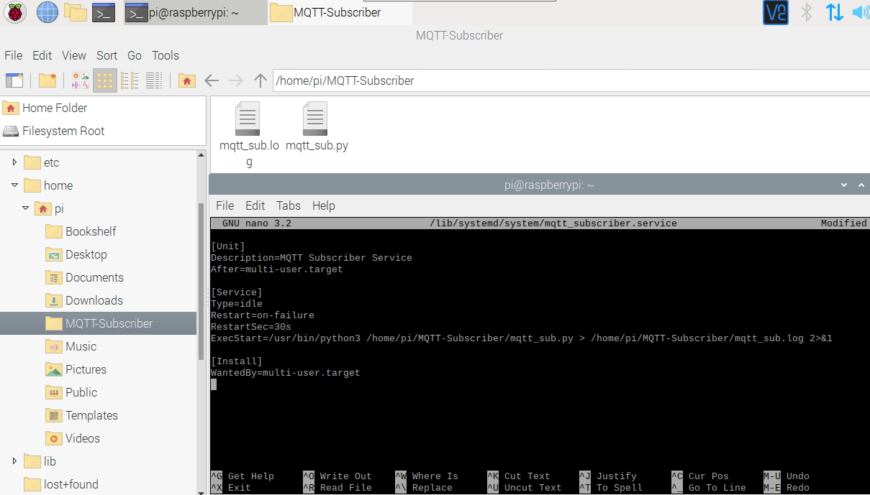

The permission on the unit file needs to be set to 644:

sudo chmod 644 /lib/systemd/system/mqtt_sub.service

### ****Step 2 – Configure systemd****

We tell systemd to start it during the boot sequence:

sudo systemctl daemon-reload

sudo systemctl enable mqtt_sub.service

Reboot the Pi and the custom service should run:

sudo reboot

Terminal for step1&2:

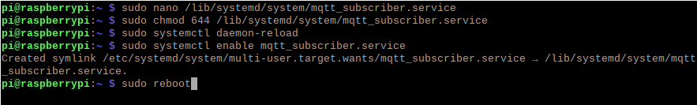

### ****Step 3 – Service Status****

To check the status of the Service we use this command.

sudo systemctl status mqtt_subscriber.service

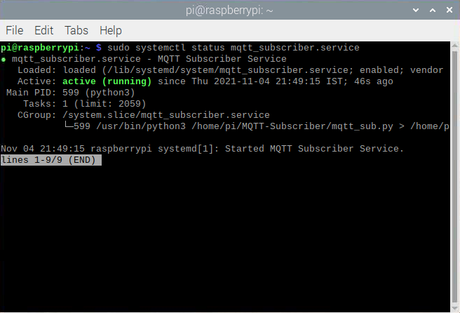

References:

<https://www.dexterindustries.com/howto/run-a-program-on-your-raspberry-pi-at-startup/>

<https://ma.ttias.be/auto-restart-crashed-service-systemd/>